# Project Submission Report

## 1. Project Overview (Point-Wise)

### ✅ Key Features Implemented

• Student registration and management.

• Linking students with specific courses and subjects.

• Exam scheduling and marks entry system.

• Automatic grade calculation based on marks.

• Role-based login system (Admin/Teacher/Student).

• Timetable and room management.

### 🛠️ Technologies Used

• Language: C#

• Framework: WinForms

• Architecture: MVC

• Database: SQLite

• IDE: Visual Studio

### ⚙️ Challenges Faced and Solutions

• Issue: Foreign key constraints in SQLite.  
 Solution: Applied proper constraints and used JOIN queries effectively.

• Issue: Validating user input to prevent crashes.  
 Solution: Used error handling, data validation, and try-catch blocks.

• Issue: Role-based access logic.  
 Solution: Used conditional role checks and secured form redirections.

## 2. Code Samples (Screenshots)

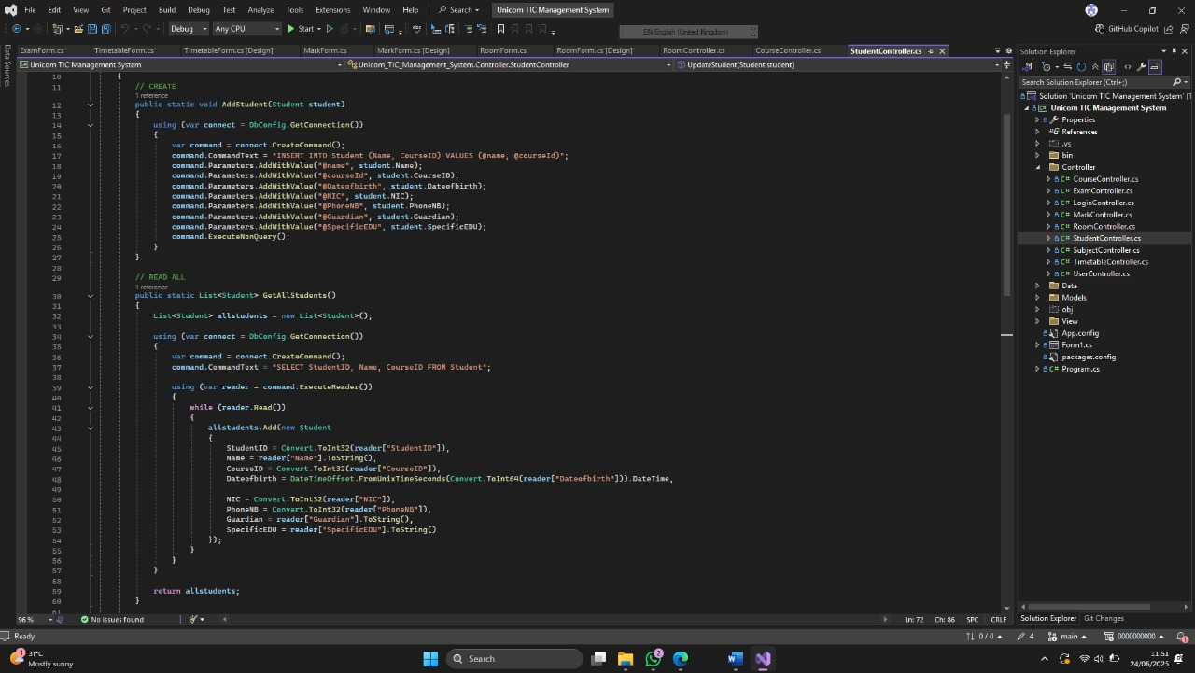[StudentController.cs] - (Add students() , GetAllStudent())

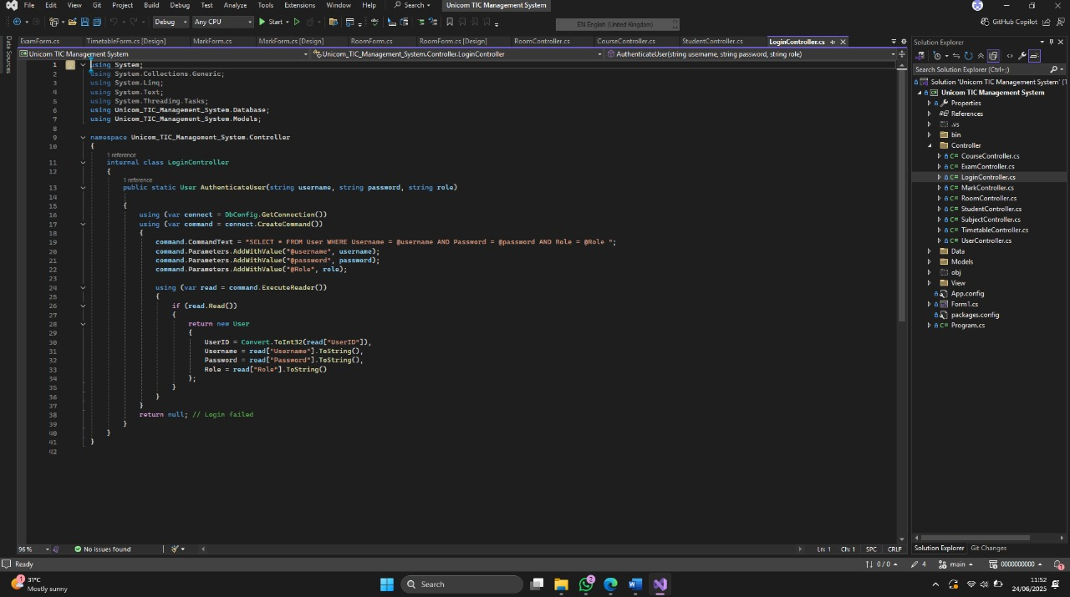

[LoginController] –(User authentication and role validation.)

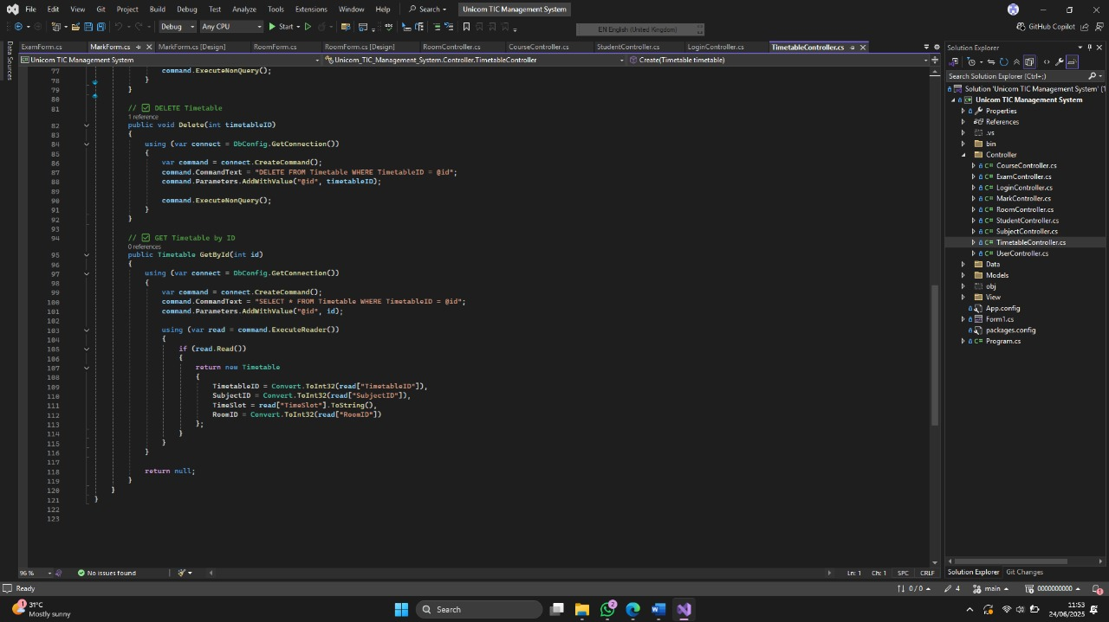

[TimetableController.cs] – (GetbyID()method)

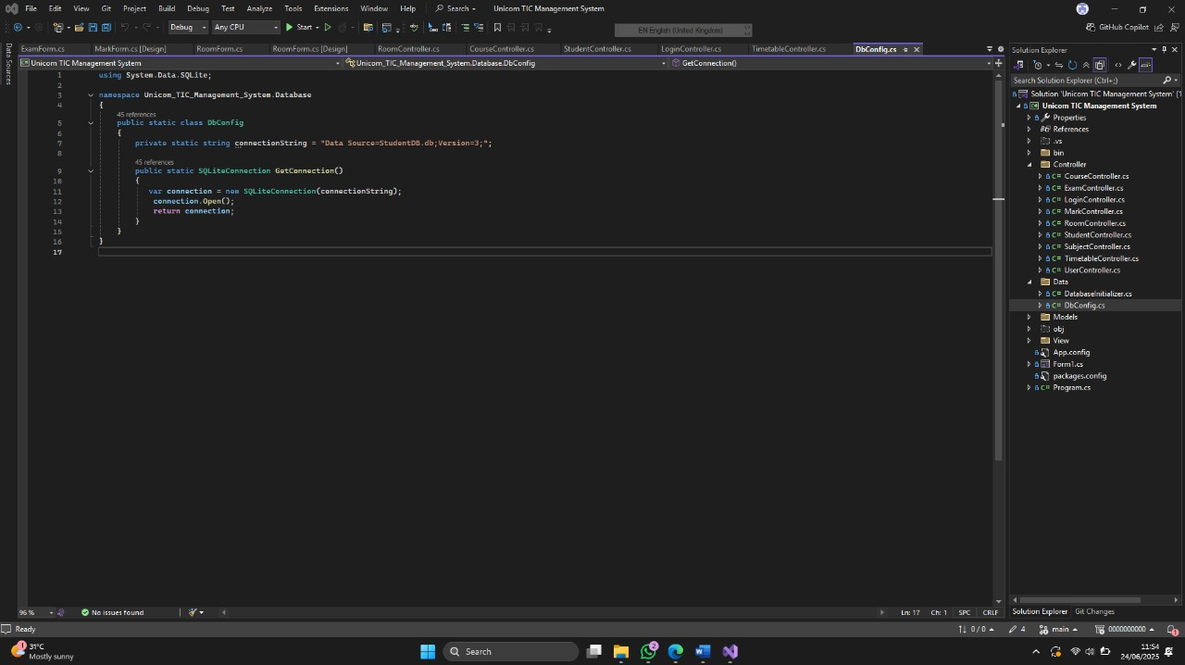

[Studentform.cs] – (input validations and UI combo , datetime picker)

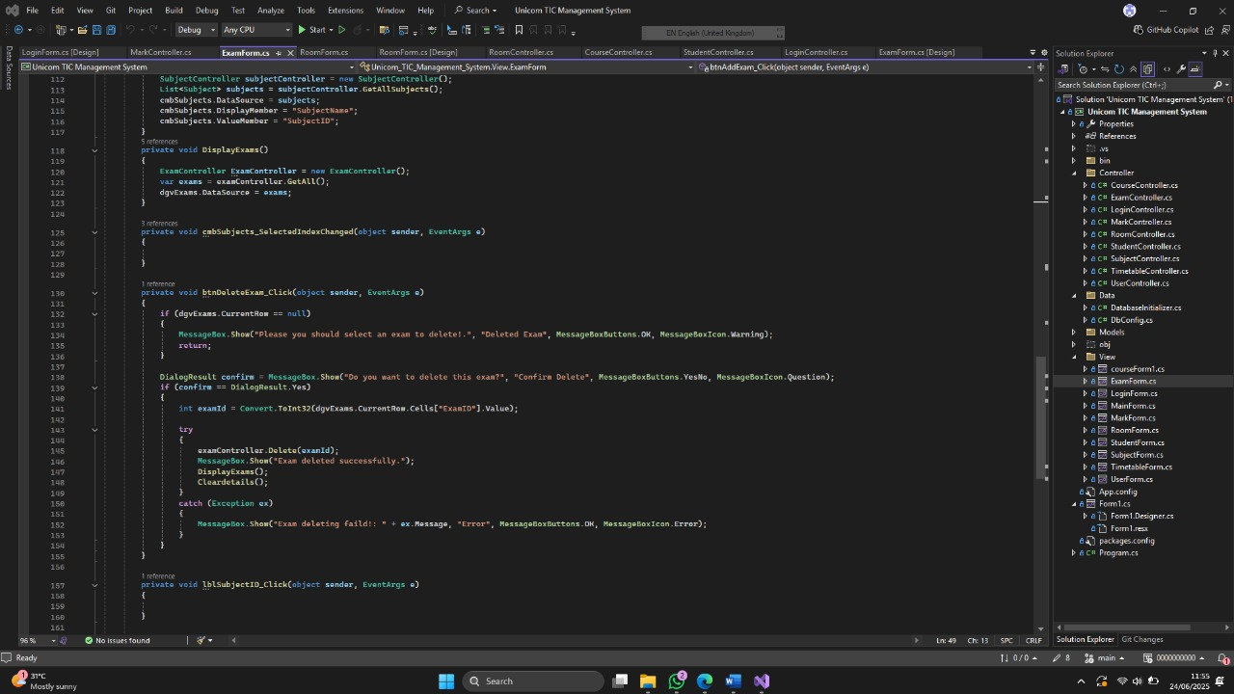

[DBCongic.cs] – (SQLite connection , command execution logic)

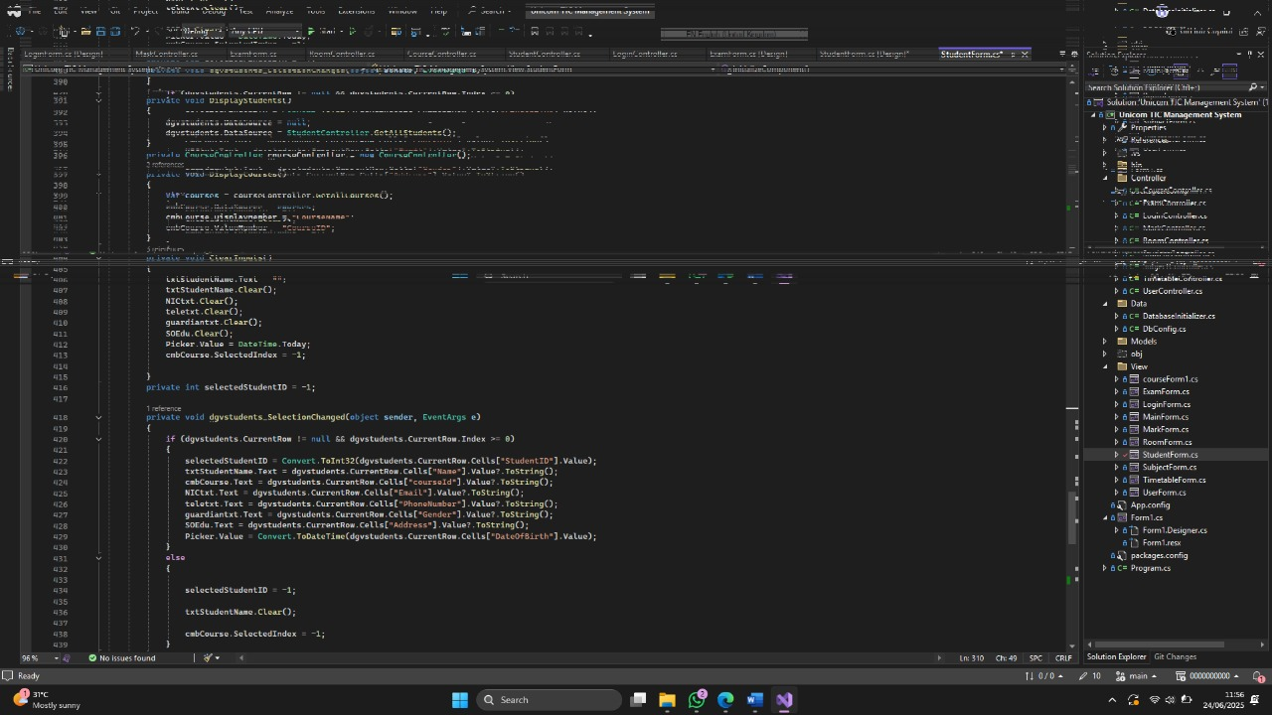

[Errorhandling]( try-catch , messagebox uses)

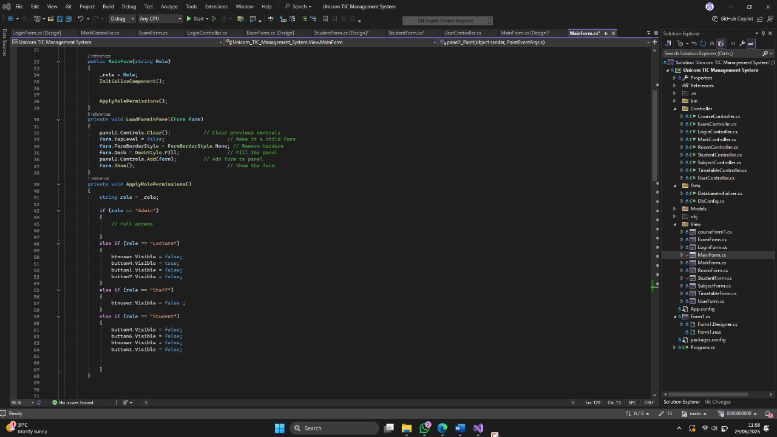

[MainForm.cs] (role based panel open)